**Mohammed Shahnawaz Khan 19/07/2024 Executing Today session Commands**

* Create a Directory Command (mkdir) and Deleted Command (rm -rf file name)

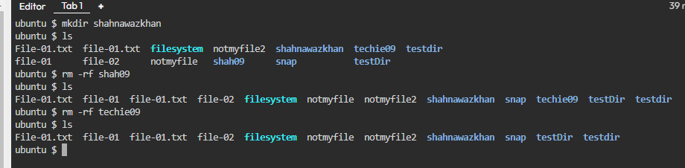

* Entering into the Directory and know the location (pwd) and how to switch (cd file name)

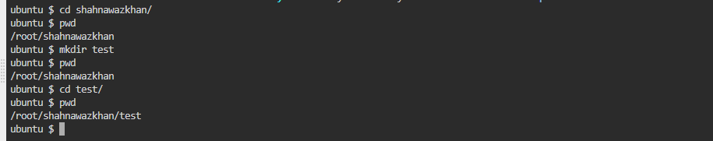

* Change Directory (cd ..) for back to the Main File and I want to root location (cd ../..)

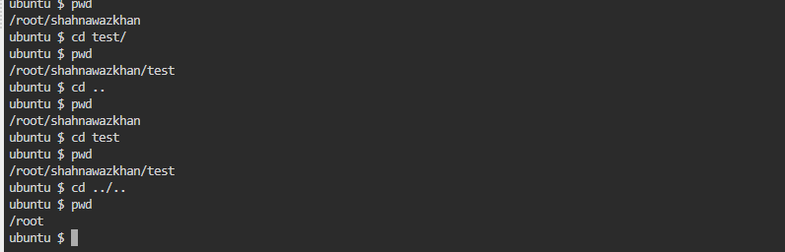

* If you want to create folder under folder (mkdir -p a/b/c/d)

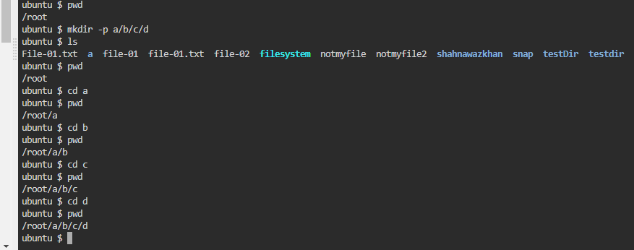

* Deleting all file in one command (rm -rf *)

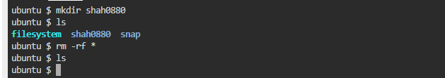

* Creating a file with 0 size (touch file name) and How to add content this file (vi file name)

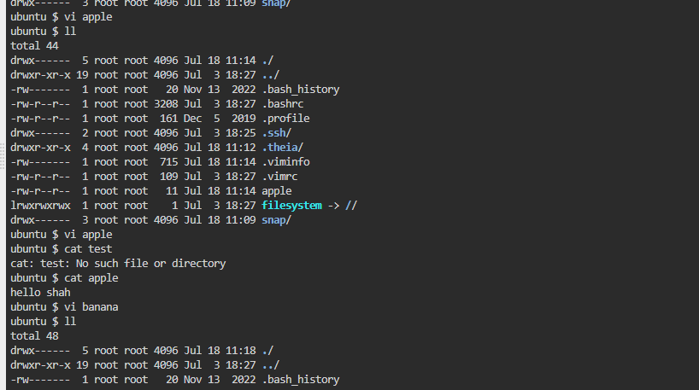

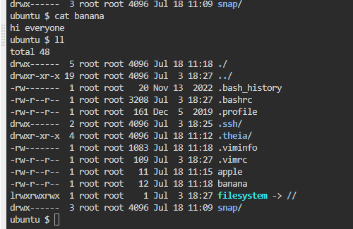

* Deleting a file which is previous (rm file name)



* Creating a multiple file with 0 size

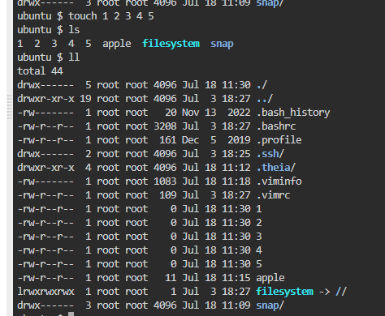

* Rename the file (mv 1st file to 2nd file names)

